Q1.
Answer is D.

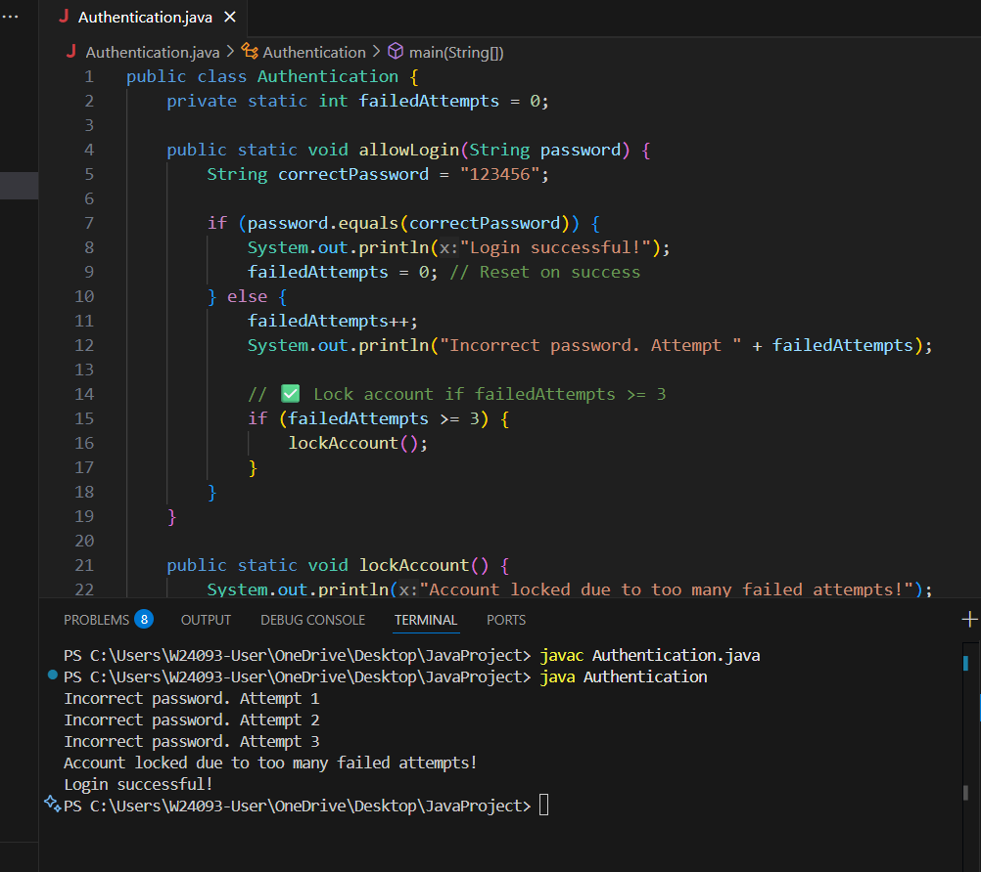

A: Works only if the counter is exactly 3.it is fail if More than 3 or less than 3.

B: Doesn’t directly handle the lock condition itself.

C: Can handle fixed value.But doesn’t handle failedAttempts>3.

D: correct,Locks account when attempts reach 3 or more.

Q2.
Answer is A.

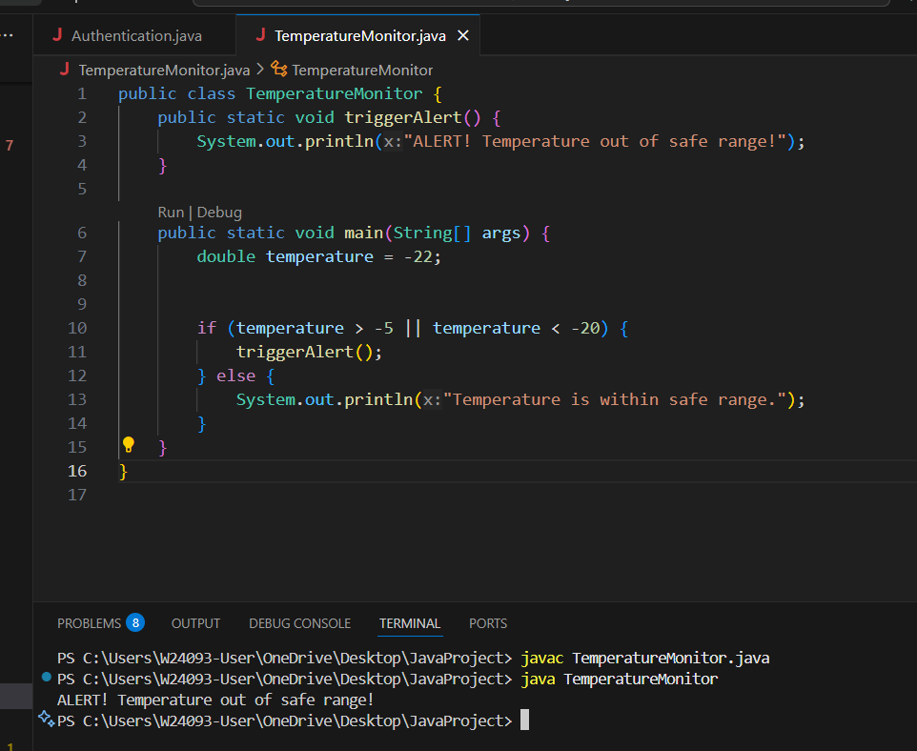

A: Used Logical OR is correct.

B: Incorrect. No temperature can be simultaneously > -5 AND < -20.

C: Incorrect comparison

D: Switch cannot handle range comparisons. Invalid syntax.

Q3.
Answer is C.

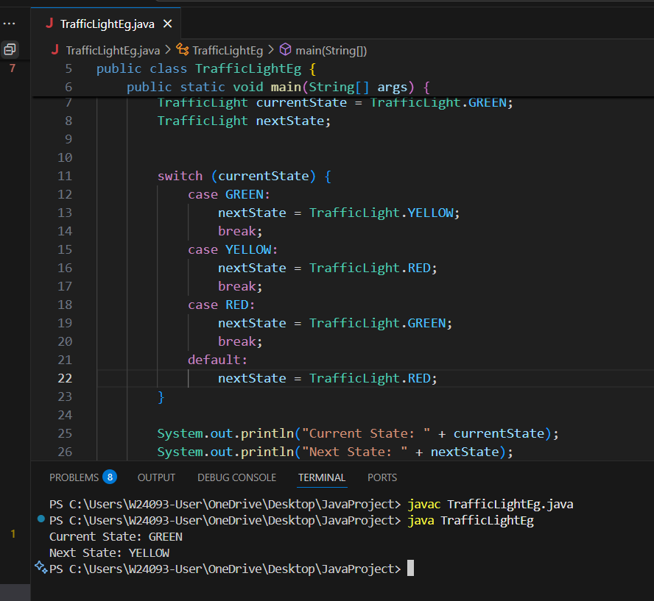

A: Works, but can become less readable for many states.

B: Not ideal for state mapping.

C: Best choice. Maps each state to the next clearly and readably.

D: Not suitable for mapping current traffic light states.

Q4.
Answer is B.

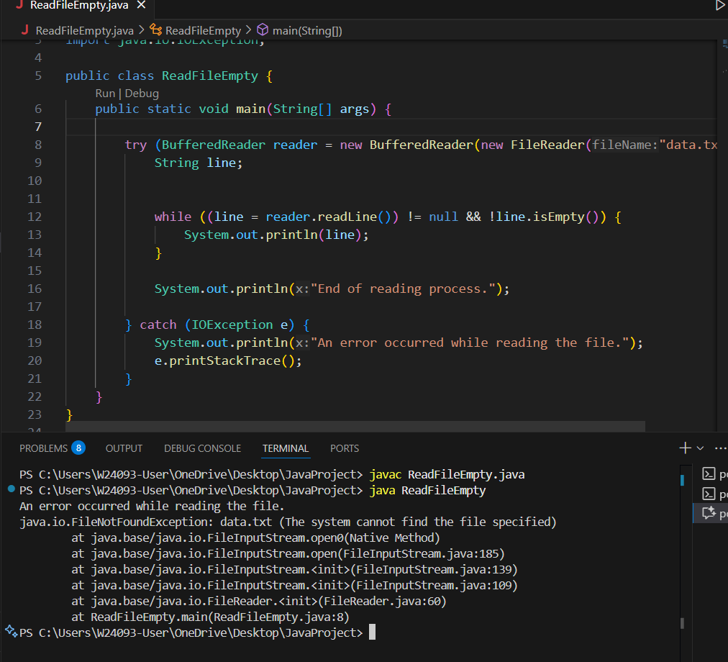

A: Reads all lines until EOF, but does not stop on empty line.

B: Correct. Stops on either EOF or empty line.

C: Reads first line without checking empty, so may process an empty line.

D: Requires reading entire file into memory first; not efficient for large files. Break logic works, but less optimal.

Q5.
Answer is A.

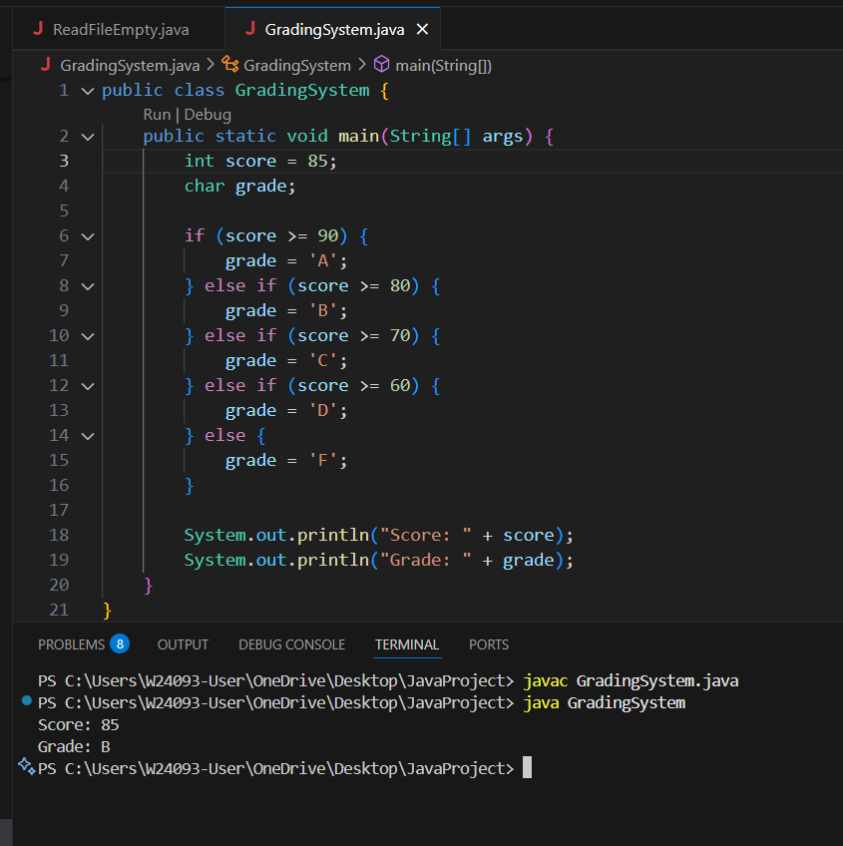

A: Perfect for checking range conditions sequentially. Clean and readable.

B: Possible but less readable.

C: Works for ranges, but nested ternary becomes hard to read and maintain.

D: Loops are for repetition, not one-time range checking.

Q6.
Answer is A.

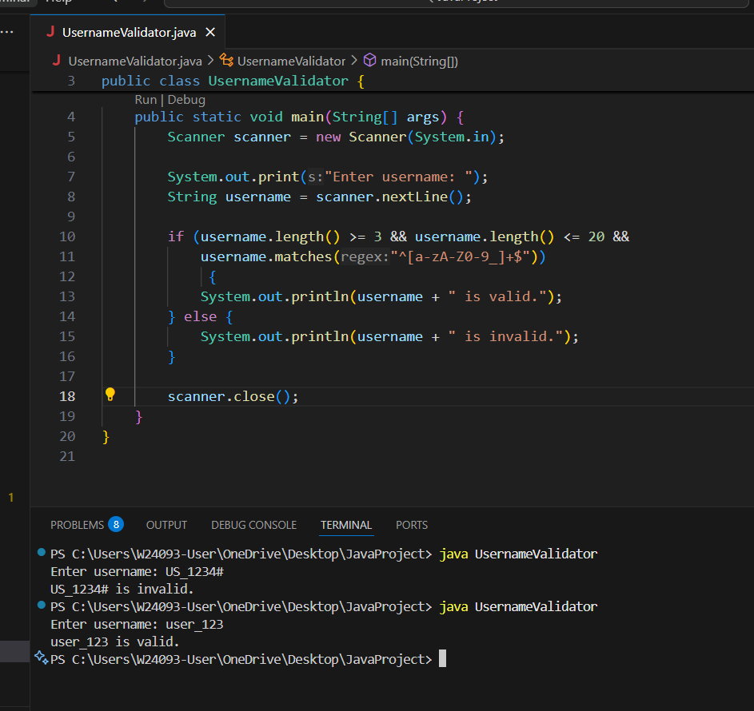

A: Correct. Checks length and regex together. Clean and readable.

B: Wrong Logic.

C: Wrong Logic.

D: Loops are unnecessary for single validation. Using while here is overcomplicated and confusing.

Q7.
Answer is B.

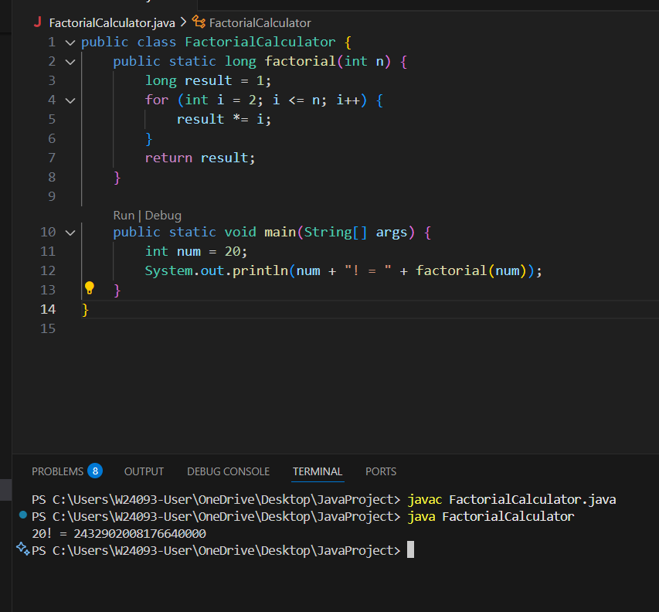

A: Possible, but less efficient.

B: Efficient, safe, no recursion, easy to read.

C: Not ideal for numbers up to 20.

D: Slightly slower than simple for loop.

Q8.
Answer is C.

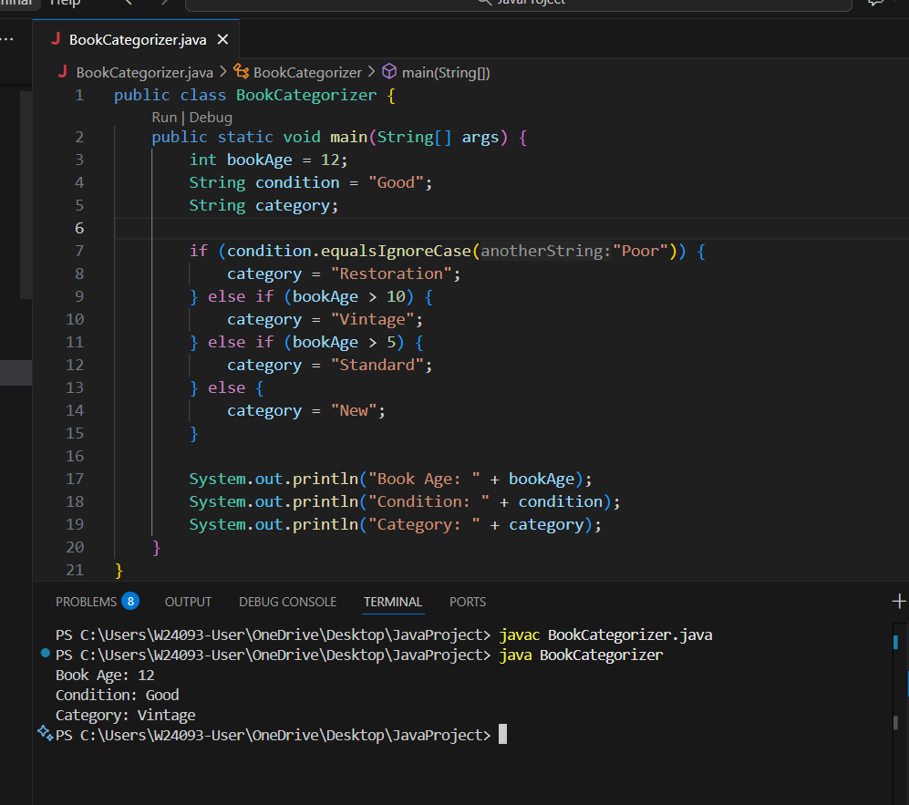

A: Works for age, but ignores ‘Poor’ condition.

B: Invalid syntax

C: Nested if-else is Correct. Handles priority condition, then age ranges. Clean and readable.

D: Loop is unnecessary.

